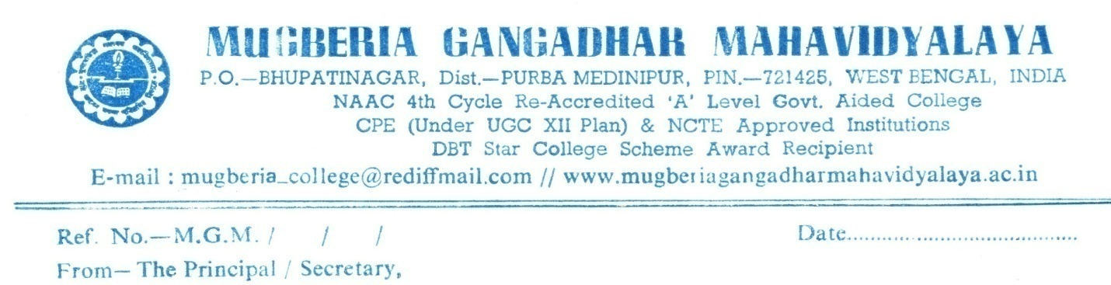

**Mentor Mentee Programme 2023-2024**

(11.08.2023)

Mentor Mantee program in the Department of Music, Mugberia Gangadhar Mahavidyalaya, Dated 11.08.2023

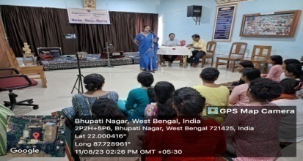 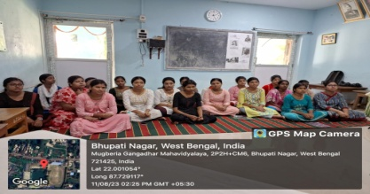

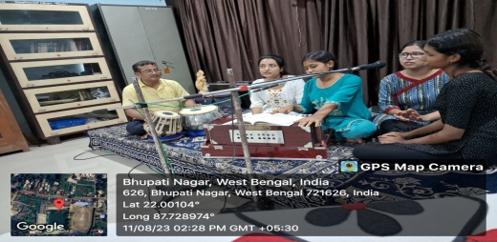

<https://twitter.com/MugberiaM/status/1690210728748421120/photo/1>

(11.08.2023)

(11.08.2023)

Mentor Mantee program in the Department of Music, dated 11.08.23

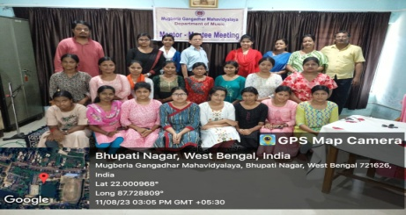 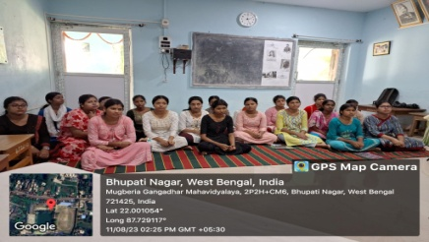

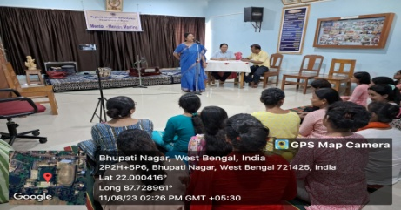 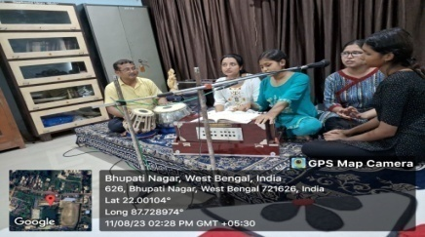

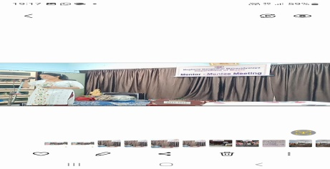 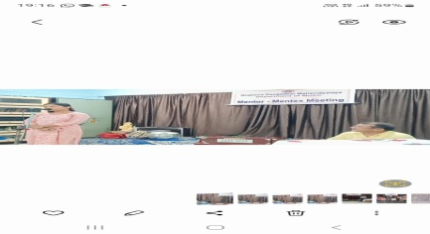

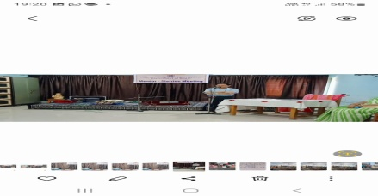 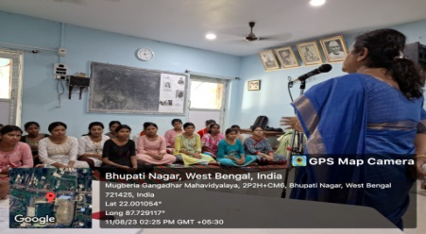

<https://twitter.com/MugberiaM/status/1690358453964001280/photo/1>

<https://twitter.com/MugberiaM/status/1690360539669762048/photo/4>

The mentor group from Brainware University participated in an exchange program in innovative projects such as mushroom , biogas , vermicomposting, and pond water into drinking water. This event was organized by the I ICouncil, Mugberia Gangadhar Mahavidyalaya, on May 16, 2024.

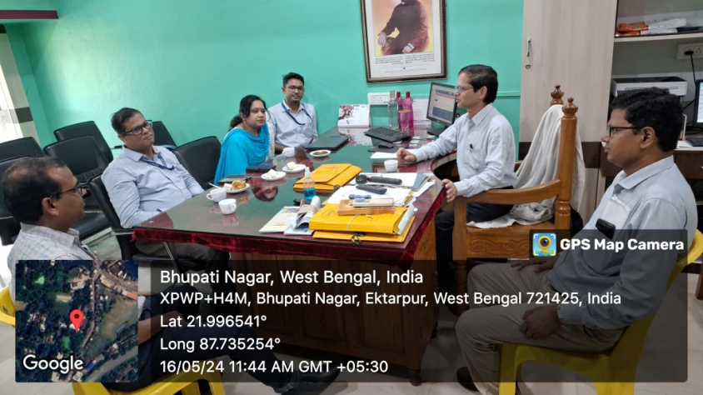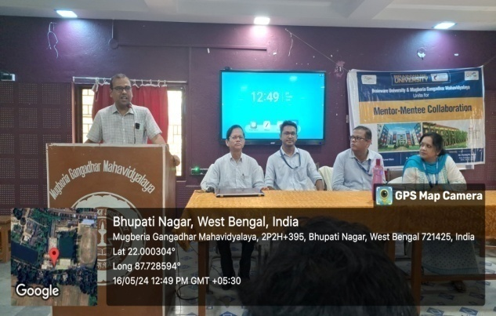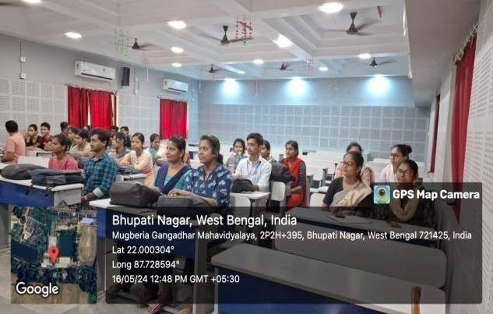

<https://x.com/MugberiaM/status/1791850106544607459/photo/1>